Link: <http://www.studytonight.com/computer-networks/unbounded-transmission-media>

**Replace** the existing text **completely** with the following:

**Radio Waves:**

Electromagnetic waves ranging in frequencies between 3 KHz and 1 GHz are normally called radio waves.

Radio waves are omnidirectional. When an antenna transmits radio waves, they are propagated in all directions. This means that the sending and receiving antennas do not have to be aligned. A sending antenna send waves that can be received by any receiving antenna. The omnidirectional property has disadvantage, too. The radio waves transmitted by one antenna are susceptible to interference by another antenna that may send signal suing the same frequency or band.

Radio waves, particularly with those of low and medium frequencies, can penetrate walls. This characteristic can be both an advantage and a disadvantage. It is an advantage because, an AM radio can receive signals inside a building. It is a disadvantage because we cannot isolate a communication to just inside or outside a building.

**Omnidirectional Antenna:**

Radio waves use omnidirectional antennas that send out signals in all directions.

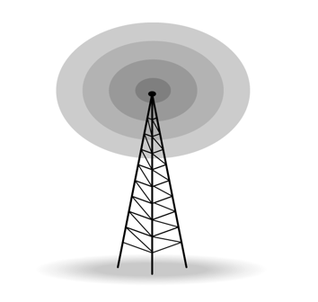

**Applications:**

The omnidirectional characteristics of radio waves make them useful for multicasting in which there is one sender but many receivers.

AM and FM radio, television, maritime radio, cordless phones, and paging are examples of multicasting.